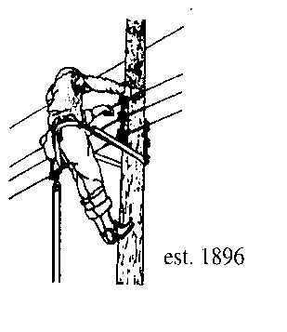
Village of Lyndonville Electric Department
PO Box 167, 119 Park Avenue, Lyndonville 05851

TRUSTEE BOARD MEETING
Meeting Agenda
Meeting Title |  |  | Trustee Meeting | Start Time | 5:30 pm
Date |  |  | 5/15/23 | Location | Muni Board Rm
ITEMS TO BE DISCUSSED
 |  | Agenda Adjustments / Approval |  |  |  | 1st |  | 2nd
 |  | Prior Meeting Minutes Approval |  |  |  | 1st |  | 2nd
 |  | Public Comment
 |  | E.V. Charging Station Study
 |  | VPPSA, AMI Project Contract
 |  | Proposed Solar Battery Storage Project
 |  | SQRP Report
 |  | Finance Update
 |  | Other Business
 |  | Adjournment |  |  |  | 1st | 2nd
MEETING NOTES
1
2
3
4
5
6
7
8
9
10

